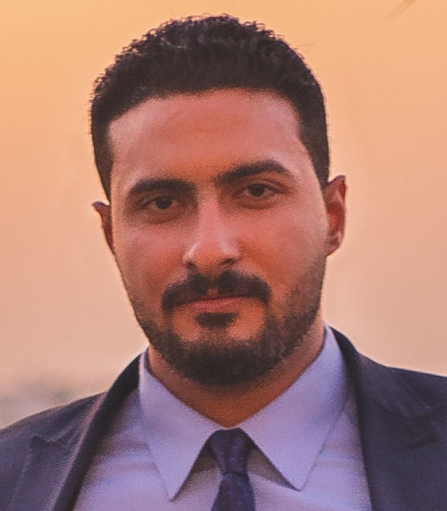
Address : 57th El salam street Ainshams , Cairo , Egypt .
E-mail shawkysaleh06@gmail.com
Mobile : +20-11- 42390270 .

Personal Data :
▪ Name : Shawky Hassan Shawky Saleh.
▪ Date of Birth : January 1st , 1993.
▪ Gender : Male .
▪ Relgion : Muslim.
▪ Nationality : Egyptian.
▪ Military : Exempted.
▪ Marital status : Single.

Education :
- Date Of Graduation : Septemper, 2015
- Bachelor Degree of Foreign Trade Economics Department
- Faculty : Commerce
- University : Helwan
- Final Year Grade : Good .
- Graduation Grade : Acceptable .
- May , 2009 : General Secondary Certificate From Ain Shams School - Graduation Degree : 80% .

Languages :
Arabic  Native | English  Reading : Good  Writing : Good  Speaking : Average | German  Reading : Good  Writing : Average  Speaking : Average

Work Experience:
Previous Job : | - Position : Property insurance specialist.  - Company : Eid selim – Lawyering firm.  - Duties : Vehicles insurance , accidents insurance inspection including information documents extraction and pursuing the insurance documents of the concerned personnel.  - Duration : From 2010 till 2015
Previous Job : | - Position : Documentation specialist.  - Company : Misr insurance company.  - Duties : Sales management and Public relations .  - Duration : From ( January – 2015 ) till ( January – 2016 ) .
Previous Job : | - Position : Documentation specialist.  - Company : Media fire – Contracting firm.  - Duties : Financial and documentation management.  - Duration : From ( October – 2018 ) till (December 2018 ).
Previous Job :  Previous Job : | - Bank Audi.  - Position: sales management.  - Duration : From ( November – 2019 ) till (September – 2020 )  - Chubb Life  - Position sales maangment  - Duration : From (January - 2021) till ( October - 2021).
General Skills:
Communication Skills | Good
Computer Skills | Good
Personal Skills and activities:
- Boxing and weight lifting.
A few Words about myself:
- Quick learner , excellent people and communication skills , ambitious and ready.

