Ahmed Hassan Ali
Curriculum Vitae

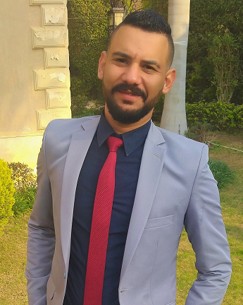

◆ Career Objective:

Seeking a dynamic position and challenging career with reputable organization where my academic background and interpersonal skills would be exposed to a challenging work environment, allowing room for self- development and open career path.

◆ Personal Information

Name: Ahmed Hassan Ali Hassan

Date of Birth: 1st of November 1990

Age: 28 years’ old

Nationality: Egyptian

Military Service: Completed

Marital state: Single

Language:
Arabic Mother tongue
excellent English written, good English spoken

Address: Compound Ramses Residence, Investors district 5.
Villa 6, El Shrouk City.

Mobile number: 01060073393
e-mail: a.hassan_90@hotmail.com

( private car license and got a car )
◆ Certificate

Academic degree in Business administration
(Major) Marketing & management from Arab Open University (AOU)

Marketing & management Certificate from Open University UK

◆ Other Certificate

❖ Human Resource Diploma from the Canadian Training Centre

❖ Project Management: The Basics for Success
from University of California, Irvine

◆ Computer Skills:

Excellent knowledge of Microsoft Windows
Excellent knowledge of Microsoft Office (Word, Excel, Power Point)
Excellent knowledge of Internet applications

◆ Other skills

❖ online marketing & Selling Skills
❖ Communication & Negotiation skills
❖ internet self-studding and research’s
❖ social media advertising and fb ads

◆ Work Experience:

❖ from August 2020 till now own and operate a wedding planning business called
" EventRix "

❖ from January 2020 to September 2020 real estate sales representative at landmark property finder

❖ from august 2019 till December 2019 Delivery associate at “ Breadfast “

❖ April 2019 – November 2019 Branch Manager at “Olio Frozen Food Company “

❖ march 2016 – November 2016 Branch Manager at stationery house called “ i-Book “ located in Madinaty

❖ October 2015 - January 2016: Sales Representatives at " El Deeb Academy " Health Club

❖ 2013 till 2015
Field worker’s coordinator in " Pioneer for construction and Decoration "

◆ other Work Experience:

❖ ushering in different events with (red bull & Winston tobacco)
❖ distribution seller on clothing industry
❖ network marketing and selling online, social media marketing
❖ Uber driver from time to time

